**Project Report: Laptop Store**

**Table of contents:**

1. **Group members with GitHub**
2. **Project description**
3. **Software and IDE requirements**
4. **ERD, Relational Database Schema and group contribution**
5. **Demo**
6. **References**
7. **Note**
8. **Conclusion**

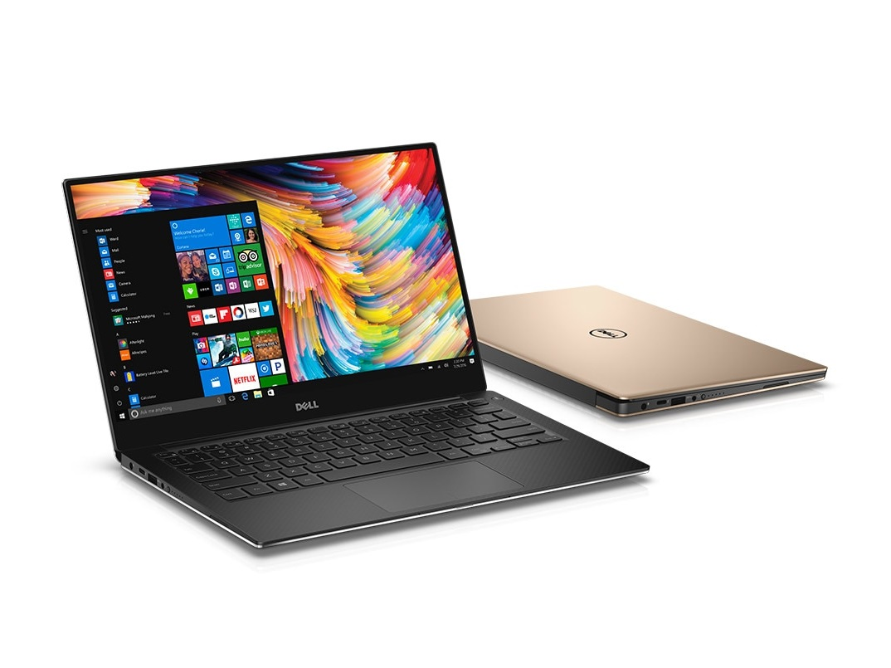

1. **Group members with GitHub**

Đỗ Thái Anh Huy ITITIU16095 <https://github.com/KiroHikaru>

Phan Nhân ITITIU17090 <https://github.com/Nhanphan1309>

Trần Lê Minh Trung ITITIU16138 <https://github.com/TranLeMinhTrung>

Group project GitHub: <https://github.com/HCMIU-CSE-DATABASE2019>

1. **Project description**

Whenever needing a new laptop, you will think about going to a laptop store or visiting an online shop website. With the convenience of the Internet, people can buy a product online without going directly to the shop.

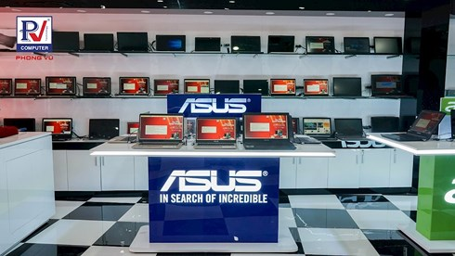

Products in a shop are often organized into disciplines (common, business, gaming, workstations, …). After accessing the website, customers freely select and buy a laptop. When finishing choosing of laptops, they go to visit the shopping cart to make their payments.

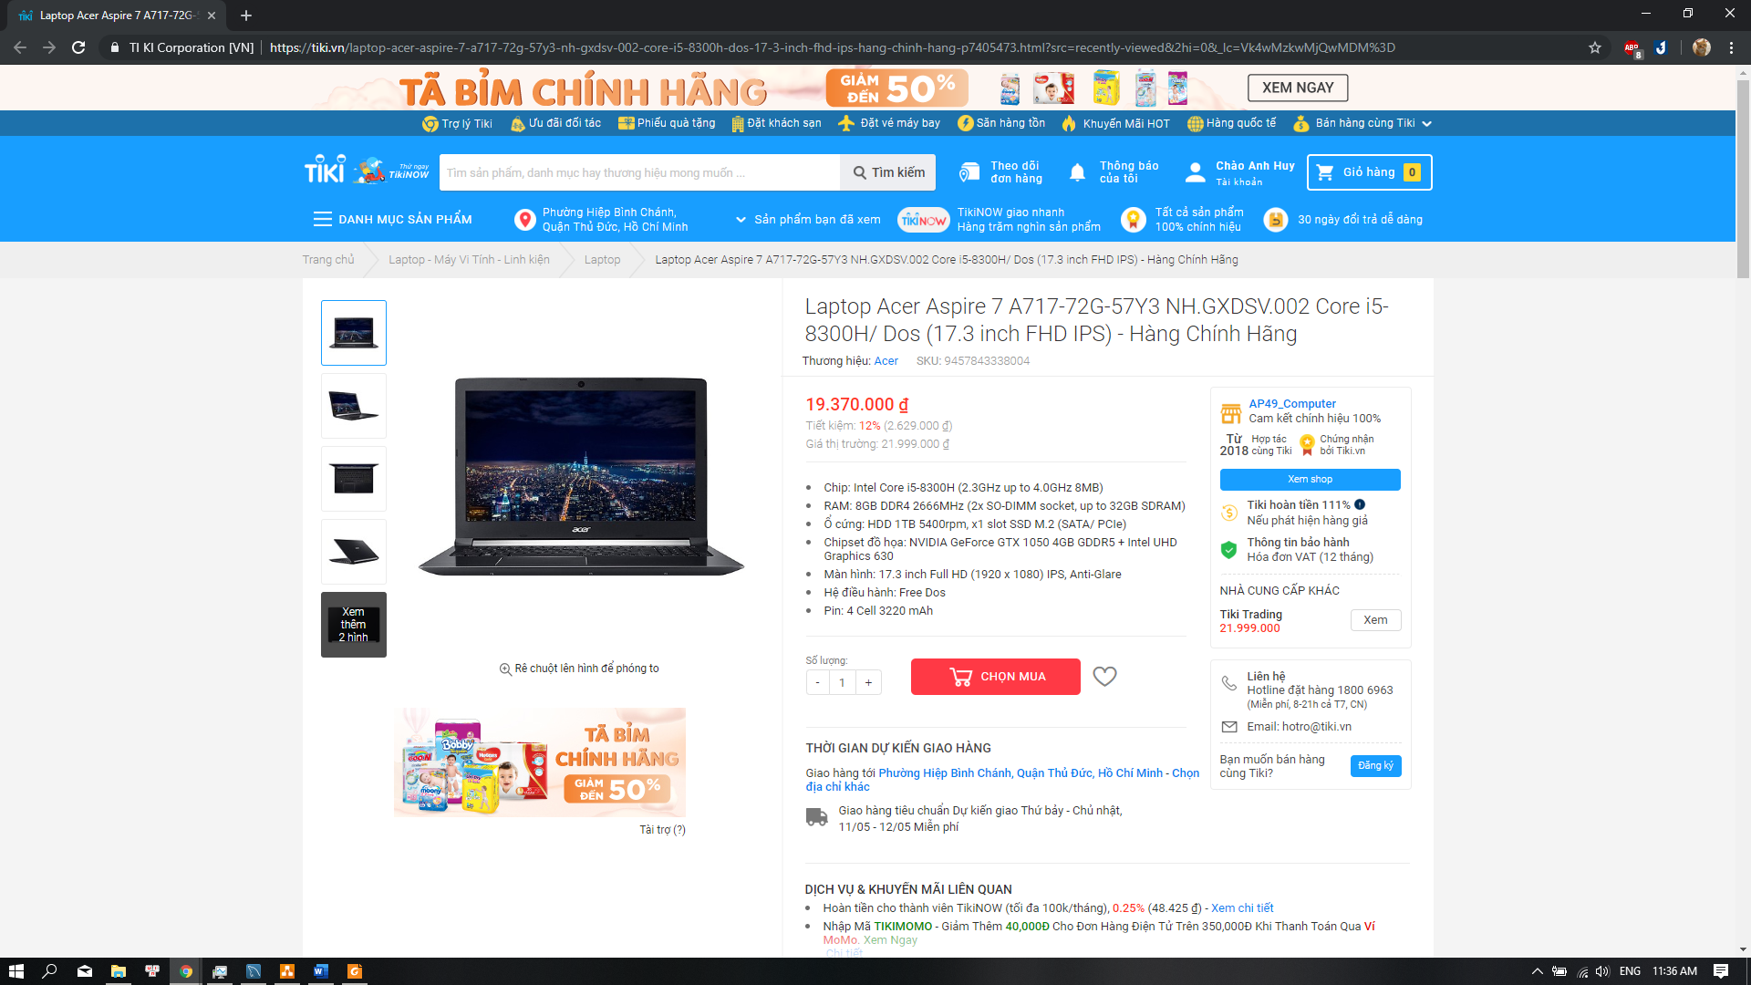

Features added on the website:

- View laptop’s specification

- Sorting laptop (Eg: by price)

Features will be included on a website in the future:  
- Search / Advanced search laptops

- Sign up, sign in and sign out

- Shopping cart

- Payment

1. **Software and IDE requirements**

IDE: Netbeans 8.2

* Tomcat 8.0.25.0 server
* Maven project
* MySQL Connector 8.0.15

SQL type: MySQL wih MySQL Workbench 8.0 CE

1. **ERD, Relational Database Schema and group contribution**

Open project folder or GitHub link for more details.

1. **Demo**

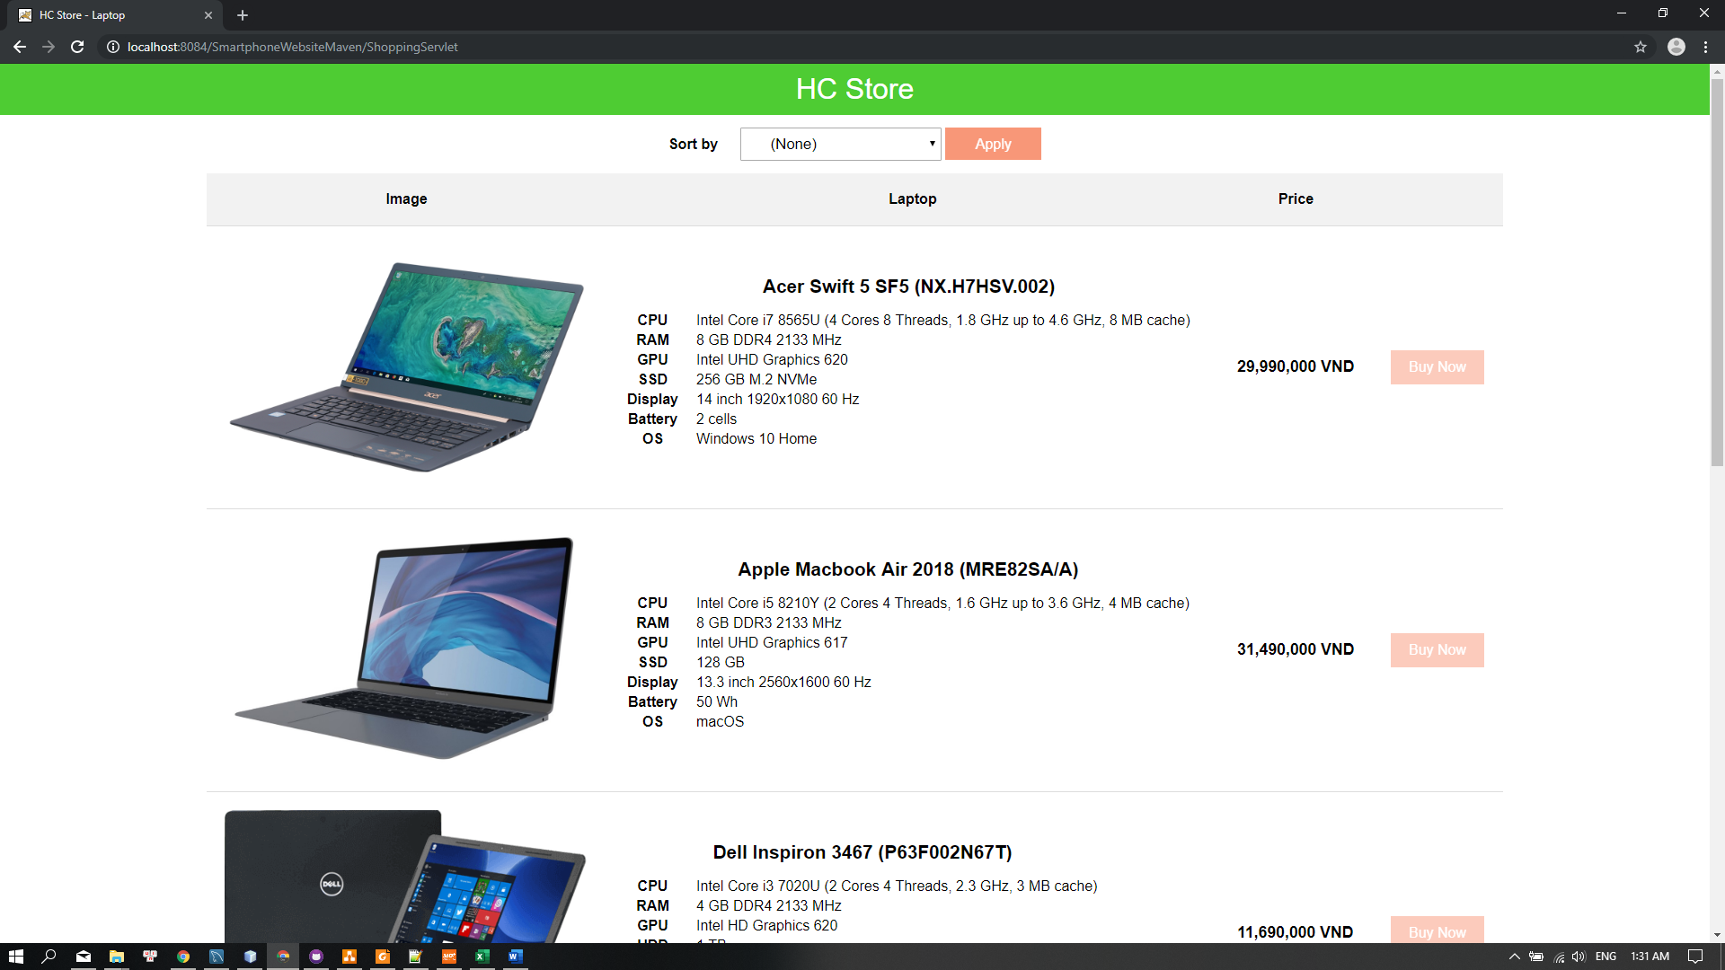

*Website UI*

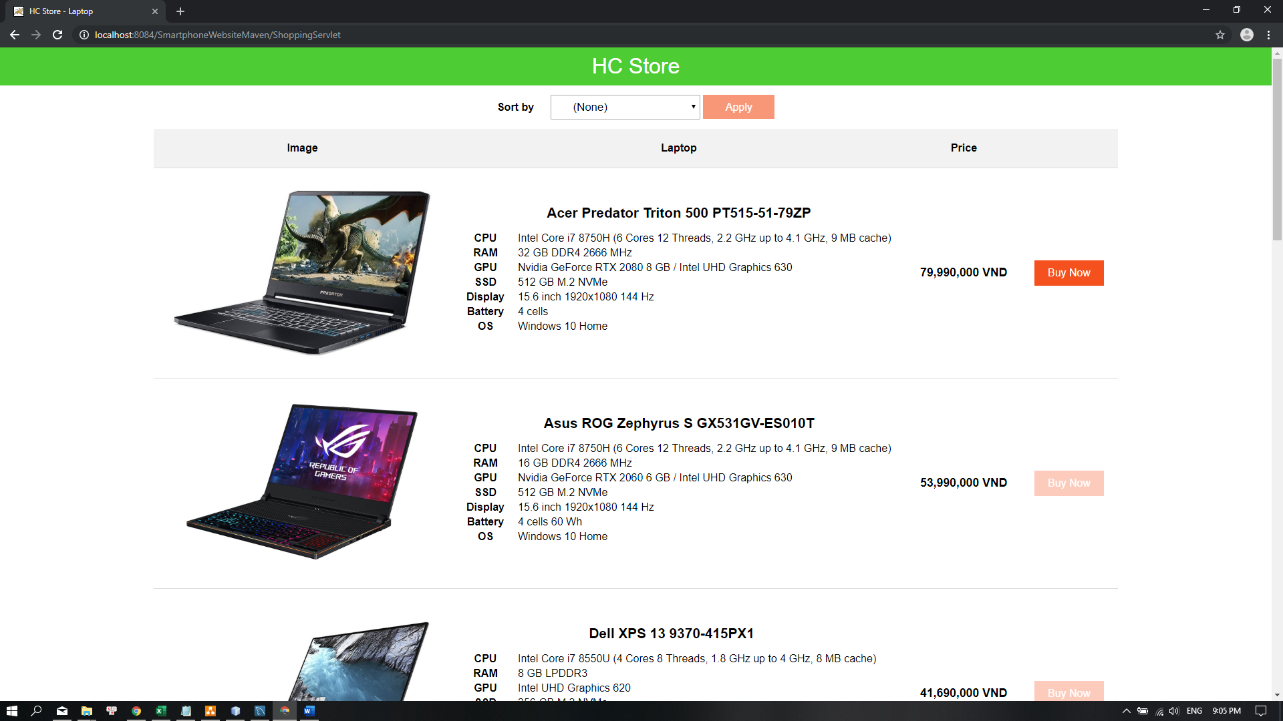

*Sort laptops by price in descending order*

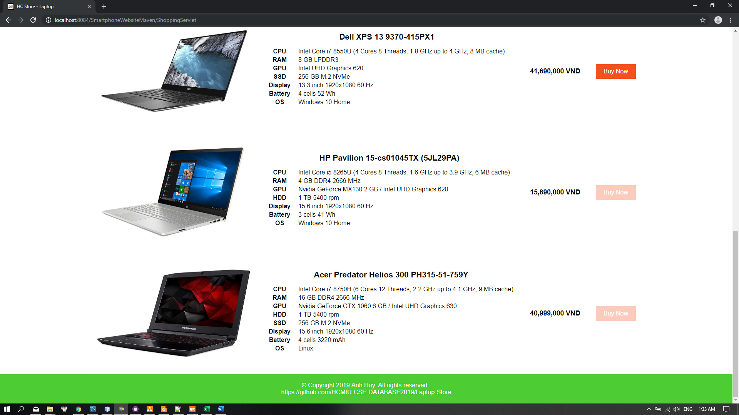

*Bottom of a website*

1. **References**

Intel CPU specification (7th and 8th gen):

<https://en.wikipedia.org/wiki/Kaby_Lake>

<https://en.wikipedia.org/wiki/Coffee_Lake>

Intel integrated GPU specification:

<https://en.wikipedia.org/wiki/Intel_Graphics_Technology#Kaby_Lake_Refresh_/_Amber_Lake_/_Coffee_Lake_/_Whiskey_Lake>

AMD CPU specification (Ryzen 2nd gen):

<https://www.amd.com/en/products/specifications/processors>

<https://en.wikipedia.org/wiki/List_of_AMD_Ryzen_microprocessors>

Nvidia GPU specification (900, 10 and 20-seires):

<https://en.wikipedia.org/wiki/GeForce_900_series>

<https://en.wikipedia.org/wiki/GeForce_10_series>

<https://www.nvidia.com/en-us/geforce/gaming-laptops/20-series/>

AMD GPU specification (Radeon Pro 500 Series):

<https://en.wikipedia.org/wiki/List_of_AMD_graphics_processing_units#Radeon_Pro_500_Series>

Apple Macbook specification:

<https://everymac.com/systems/apple/macbook/index-macbook.html>

<https://everymac.com/systems/apple/macbook-air/index-macbook-air.html>

<https://everymac.com/systems/apple/macbook_pro/index-macbookpro.html>

Laptop specification and image from e-commerce websites:

<https://www.thegioididong.com/laptop>

<https://fptshop.com.vn/may-tinh-xach-tay>

<https://phongvu.vn/macbook-phu-kien-715.cat?pv_medium=m-4>

<https://tiki.vn/laptop/c8095?src=static_block&_lc=Vk4wMzkwMjQwMDM%3D>

<https://tanthanhdanh.vn/danh-muc/laptop/>

**7. Note**

* MySQL does not allow to name the table or database in uppercase, or have a space character.
* Sometime MySQL does not allow to have the same column names from many tables.
* Please visit the GitHub link and download the project content if you want for the latest version.

**8. Conclusion**

* Database (Model) is a one of the three parts of Model-View-Controller (MVC) which is an architectural pattern.
* “Laptop Store” is based on the MVC model.
* This project is much more simpler comparing to the real commerce project.
* MySQL’s syntaxes are more complex than SQL Server.
* MySQL does not support FULL OUTER JOIN syntax.
* MySQL supports more operating systems and more programming languages than SQL Server.
* ERD is extremely useful for database management because of its complexity.
* It is painful to collect thousand of information and insert into the database by hand in a limited time.
* Handling null values in records is necessary for the string concatenation in SQL.

